## **Introduction**

This is a simple self assessment tool that can be used as a reference architecture to build a full-stack application. This system is built with the following technologies:

* Spring boot
* Angular
* MySQL

## **Prerequisite**

Please note that this project is saved across two Github repositories.

* Backend - <https://github.com/Stasha13/PersonalProject>
* Frontend - <https://github.com/Stasha13/PersonalProject2>

## **Project Management**

This project uses an agile methodology. Please see example board at the following link: <https://trello.com/b/eJsjIYJf/bootcamp-personal-project>

## **Running the application**

Step 1: Make a directory for your work and clone the project on both of the above Github repositories into this directory.

Step 2: Import both of these projects into the IDE of your choice.

Step 3: Once imported, run the self assessment file from the back end application. This will run Springboot (see below).

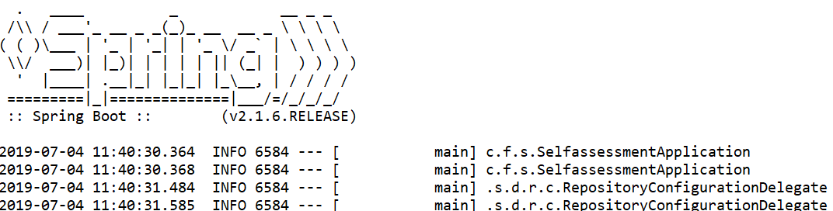

Step 4: Now you need to run the front end application. You now need to navigate to the folder that you have saved this application in and open a command line.

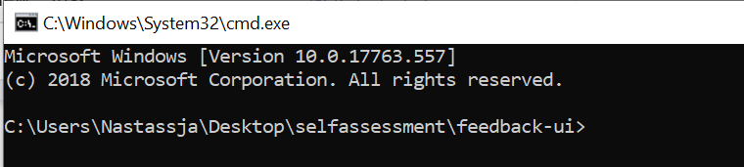

Step 5: Next in the cmd line execute the following command:

npm start

Step 6: From a browser access the app by executing the following HTTP request:

<http://localhost:4200>

Step 7: From the browser add an entry using the application. Please observe how this entry is now input into your DB.

Step 8: You can now navigate to the Admin component of the application, this will list all of the entries that have been entered. This can be accessed from:

<http://localhost:4200/admin>

Step 9: As you can see in the table, each name is hyperlinked. You can click on each name to view the entries independently. When you have finished viewing the record you can click ‘Back to all entries’ to go back to the admin table.

Step 10: You can also delete entries from the admin table. Click the delete button and this will delete the entry and refresh your page.